Chemistry 141 Name
Dr. Cary Willard
Exam 2a October 21, 2010

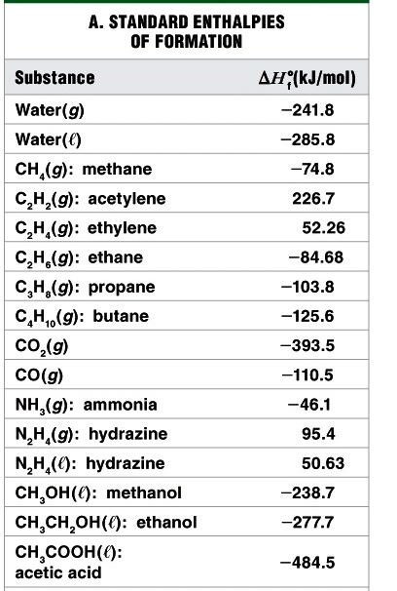
Multiple Choice (30 points)

Page 4 (5 points)

Page 5 (10 points)

Page 6 (18 points)

Page 7 (9 points)

Page 8 (16 points)

Page 9 (16 points)

Page 10 (12 points)

Total (116 points)

Percent (100 %)

All work must be shown to receive credit. Give all answers to the correct number of significant figures

Avogadros number = 6.022 x 10²³ /mol
R = 0.0821 L atm/mol K = 62.4 L torr/mol K
K = ºC + 273.16

specific heat of ice 2.06 J/gºC
specific heat of water 4.184 J/gºC
specific heat of steam 2.0 J/gºC
heat of fusion 333 J/g
heat of vaporization 2260 J/g

Grossmont College
Periodic Table
IA |  |  |  |  |  |  |  |  |  |  |  |  |  |  |  |  | VIIA | NOBLE GASES
1  H  1.008 | IIA |  |  |  |  |  |  |  |  |  |  |  | IIIA | IVA | VA | VIA | 1  H  1.008 | 2  He  4.002
3  Li  6.941 | 4  Be  9.012 |  |  |  |  |  |  |  |  |  |  |  | 5  B  10.81 | 6  C  12.01 | 7  N  14.01 | 8  O  16.00 | 9  F  19.00 | 10  Ne  20.18
11  Na  23.00 | 12  Mg  24.30 | IIIB | IVB | VB | VIB | VIIB | VIII VIII VIII |  |  |  | IB | IIB | 13  Al  27.00 | 14  Si  28.09 | 15  P  30.97 | 16  S  32.06 | 17  Cl  35.45 | 18  Ar  39.95
19  K  39.10 | 20  Ca  40.08 | 21  Sc  44.96 | 22  Ti  47.90 | 23  V  50.94 | 24  Cr  52.00 | 25  Mn  54.94 | 26  Fe  55.85 | 27  Co  58.93 | 28  Ni  58.70 |  | 29  Cu  63.55 | 30  Zn  65.38 | 31  Ga  69.72 | 32  Ge  72.59 | 33  As  74.92 | 34  Se  78.96 | 35  Br  79.90 | 36  Kr  83.80
37  Rb  85.47 | 38  Sr  87.62 | 39  Y  88.91 | 40  Zr  91.22 | 41  Nb  92.91 | 42  Mo  95.94 | 43  Tc  (99) | 44  Ru  101.1 | 45  Rh  102.9 | 46  Pd  106.4 | 47  Ag  107.9 |  | 48  Cd  112.4 | 49  In  114.8 | 50  Sn  118.7 | 51  Sb  121.8 | 52  Te  127.6 | 53  I  126.9 | 54  Xe  131.3
55  Cs  132.9 | 56  Ba  137.3 | 57  La  138.9 | 72  Hf  178.5 | 73  Ta  180.9 | 74  W  183.9 | 75  Re  186.2 | 76  Os  190.2 | 77  Ir  192.2 | 78  Pt  195.1 | 79  Au  197.0 |  | 80  Hg  200.6 | 81  Tl  204.4 | 82  Pb  207.2 | 83  Bi  209.0 | 84  Po  (209) | 85  At  (210) | 86  Rn  (222)
87  Fr  (223) | 88  Ra  226.0 | 89  Ac  227.0 | 104  Rf  (261) | 105  Db  (262) | 106  Sg  (263) | 107  Bh  (262) | 108  Hs  (265) | 109  Mt  (266) | 110  ??  (269)

58  Ce  140.1 | 59  Pr  140.9 | 60  Nd  144.2 | 61  Pm  (147) | 62  Sm  150.4 | 63  Eu  152.0 | 64  Gd  157.3 | 65  Tb  158.9 | 66  Dy  162.5 | 67  Ho  164.9 | 68  Er  167.3 | 69  Tm  168.9 | 70  Yb  173.0 | 71  Lu  175.0
90  Th  232.0 | 91  Pa  231.0 | 92  U  238.0 | 93  Np  (237) | 94  Pu  (244) | 95  Am  (243) | 96  Cm  (247) | 97  Bk  (247) | 98  Cf  (251) | 99  Es  (252) | 100  Fm  (257) | 101  Md  (258) | 102  No  (259) | 103  Lr  (260)

Lanthanide series

Actinide series

Part I – Multiple Choice (30 points)

- Thermochemistry is the study of how ________ is produced and consumed during chemical reactions.

  - heat
  - energy
  - temperature
  - work

- A student dissolving some ammonium nitrate (NH₄NO₃) in water notices that the beaker gets cooler as the solid dissolves. This is an example of a(n)

  - exothermic process.
  - combustion reaction.
  - endothermic process.
  - thermodynamic cycle.

- A group of thermochemical reactions, with known enthalpies (ΔH_{rxn}), can be used to determine the enthalpy of an unknown reaction since

  - ΔH is path dependent.
  - ΔH is an extensive property.
  - ΔH is independent of path.
  - ΔH is an intensive property.

- If the enthalpy change in a system is negative, then
  - the enthalpy change in the surroundings is negative.
  - the enthalpy change in the surroundings is positive.
  - the total enthalpy of the universe increases.
  - the total energy of the universe decreases.
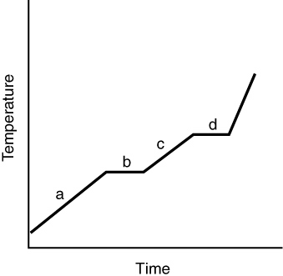
- The heating curve for a substance is shown in the following graph. The substance is initially a solid, heated to a liquid, and finally converted to a gas. Which of the line segments represents the solid → liquid phase transition?

  - a
  - b
  - c
  - d

- A 15 g piece of iron (C_{p} = 25.09 J/K · mol) is heated to a temperature of 95°C and placed into a bucket containing 4.5 gal of water (C_{p} = 75.38 J/K · mol), initially at 25°C. Eventually,
  - the water will be warmer than the iron.
  - the iron will be warmer than the water.
  - the iron will be colder than the water.
  - the iron and the water will be at the same temperature.

- Which of the following substances would be the best choice to use as an insulator?

  - CCl₂F₂ (?) (C = 0.598 J/K · g)
  - olive oil (C = 1.97 J/K · g)
  - CCl₂F₂ (g) (C = 1.047 J/K · g)
  - Hg () (C = 0.1393 J/K · g)

- Which of the following substances will require the highest column for measuring an atmospheric pressure of 0.950 atm? (Assume all the barometers have columns with the same diameter.)

  - Mercury (d = 13.59 g/cm³)
  - Ethylene glycol (d = 1.09 g/cm³)
  - Ethanol (d = 0.79 g/cm³)
  - Water (d = 1.00 g/cm³)

- The pressure of a gas is inversely proportional to

  - the volume of the gas.
  - the temperature of the gas.
  - the number of gas particles.
  - the mass of the gas.

- A car tire is inflated to 32.0 lb/in² at sea level and then driven to an elevation of 5000 ft above sea level, where the driver discovers the tire pressure is 32.1 lb/in² after allowing the tires to cool. If the driver could check it, she would discover that the volume of the tire’s inner tube has

  - decreased.
  - remained the same.
  - increased.
  - halved.

- A gas at 3.0 atm is contained in a metal cylinder. Assuming the volume of the cylinder does not change with temperature, at which temperature are the gas molecules moving the fastest (on average)?

  - T = 100°C
  - T = 75°C
  - T = 25°C
  - T = 10°C

- In an ideal gas,
  - the gas molecules do not interact.
  - the gas molecules’ volumes are negligible.
  - gas molecules do not interact, and their volumes are negligible.
  - gas molecules interact, but their volumes are negligible.

- Which of the following is unimportant when using the ideal gas law?
  - the chemical identity of the gas sample
  - the temperature of the gas sample
  - the pressure of the gas sample
  - the volume of the container holding the gas sample
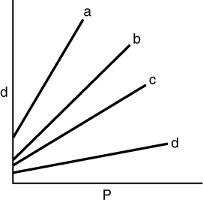
- The pressure in a container holding N₂, He, CH₄, and Ar is increased, and the densities of the four gases are monitored. Which curve is for N₂?

  - a
  - b
  - c
  - d

- The partial pressure of a gas is
  - the pressure a gas exerts in its pure state.
  - the pressure due to a gas in a mixture.
  - the same as the gas’s vapor pressure.
  - the total pressure of a mixture of gases.

Part 2 - Problems

- (5 points) A system receives 425 J of heat and delivers 535 J of work to its surroundings. What is the change in internal energy of the system (in J)?

- (5 points) A chemical engineer studying the properties of fuels placed 1.750 g of a hydrocarbon in the bomb of a calorimeter and filled it with O₂ gas. The bomb was immersed in 2.500 L of water and the reaction initiated. The water temperature rose from 20.00ºC to 25.41ºC. If the calorimeter (excluding the water) had a heat capacity of 403 J/K, what was the heat of combustion per gram of fuel?

- (5 points) An important industrial route to extremely pure acetic acid is the reaction of methanol with carbon monoxide:
Use bond energies to calculate the heat of reaction.

- (18 points) Kerosene, a common space heater fuel, is a mixture of hydrocarbons whose “average” formula is C₁₂H₂₆.
  - Write a balanced equation, using the simplest whole-number coefficients, for the complete combustion of kerosene to gases.

  - If ΔHº_{comb} (kerosene) = -1.5000 x 10⁴ kJ for the equation as written in part (a), determine ΔHº_{f} of kerosene.

  - Calculate the heat produced by combustion of 0.5000 L of kerosene (density of kerosene = 0.749 g/mL)

  - If the heat produced by the kerosene is used to heat a block of ice with a mass of 25.00 kg at -20.0ºC, what will be the state of the products and the temperature? If there is more than one state present, indicate the mass of each state present.

- (9 points) What is the effect of the following on the volume of 1 mol of an ideal gas?
  - Half the gas escapes through a stopcock (at constant P and T).

  - The temperature is decreased from 700K to 350 K (at constant P)

  - The pressure is increased from 2 atm to 8 atm (at constant T).

- (5 points) A sample of sulfur hexafluoride gas occupies a volume of 5.10 L at 198ºC. Assuming that the pressure remains constant, what temperature (in ºC) is needed to reduce the volume to 2.50 L?

- (5 points) A 75.0 g sample of dinitrogen monoxide is confined in a 3.10 L vessel. What is the pressure (in atm) at 115ºC?

- (6 points) When an evacuated 63.8 mL glass bulb is filled with a gas at 22ºC and 747 mm Hg, the bulb gains 0.103 g in mass. Is the gas N₂, Ne, or Ar?

- (6 points) “Strike anywhere” matches contain the compound tetraphosphours trisulfide, which burns to form tetraphosphorus decaoxide and sulfur dioxide gas. How many milliliters of sulfur dioxide, measured at 725 torr and 32ºC can be produced from burning 0.800 g of tetraphosphorus trisulfide?

- (10 points) Consider two 1 L samples of gas: one is H₂ and the other is O₂. Both are at 1 atm and 25ºC. How do the samples compare in terms of
  - Mass

  - Density

  - Average molecular kinetic energy

  - Average molecular speed

  - Time for a given fraction of molecules to effuse

- (7 points) Solid white phosphorus melts and then vaporizes at high temperature. Gaseous white phosphorus effuses at a rate that is 0.404 times that of neon in the same apparatus under the same conditions. How many atoms are in a molecule of gaseous white phosphorus?

- (5 points) At a height of 300 km above Earth’s surface, an astronaut finds that the atmospheric pressure if about 10.8 mmHg and the temperature is 500K. How many molecules of gas are there per milliliter at this altitude?

